Name of Student : Raghav Mahesh Sarda PRN: 25070122235
Subject: Programming with Java Semester: III
ASSIGNMENT No : 1 Year: AY 2026-27
TITLE : Java Environment Setup and Basic Program Execution

Problem Statement
Develop an application based on Java environment setup, JDK/JRE/JVM, variables, methods and constructors. and demonstrate the implementation of the concepts through suitable examples.

Learning Objectives
Understand the theoretical concepts, implement them in Java programs, analyse outputs, and apply the concepts to solve practical programming problems.

Programs
Prog1.java
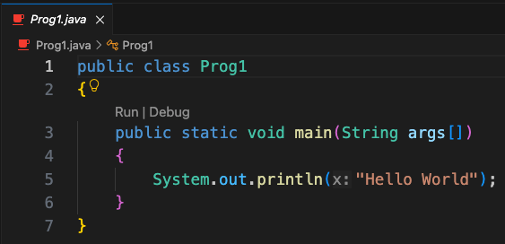

Prog2.java
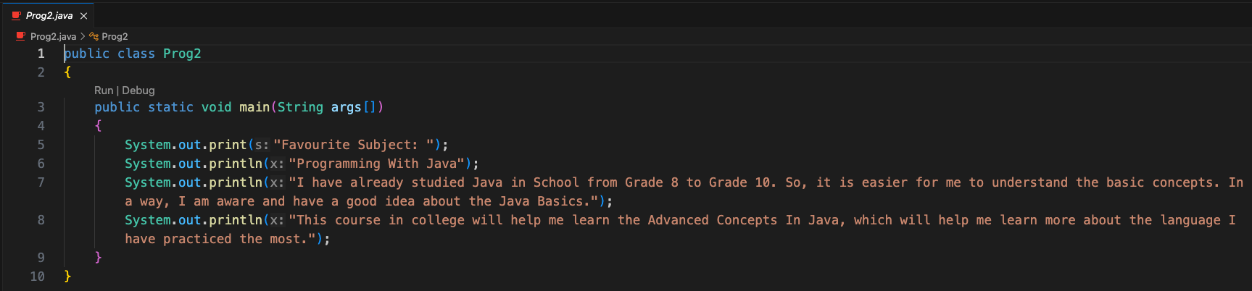
Outputs
Prog1.java
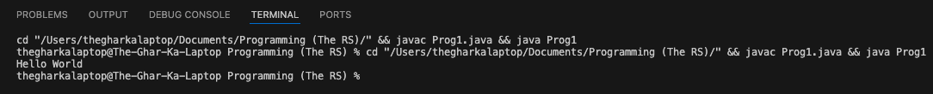

Prog2.java
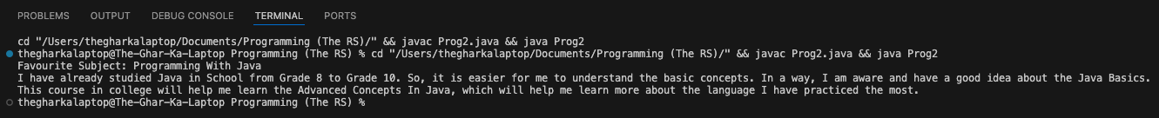

Conclusion
In this assignment, the foundational concepts of Java programming, including JDK/JRE/JVM architecture, environment setup, variables, methods, and constructors, were successfully studied and implemented. Demonstrating variables, methods, and constructor initialization provided clarity on dynamic data storage, code reusability, and object-oriented structure.

Questions
- Explain the main concept used in Java environment setup, variables and methods.
- What are the advantages of using Java variables and methods?
- How can this implementation be improved?
- What are the real-world applications?

